Coach Account / Team Creation on COYESS Tournament Website
This site is new. If you encounter any issues or have any questions when using this site please contact Jason Nester at 303 883 7490.

Please follow the instructions below on how to create your head coach account and team on the COYESS Tournament website. This document will also provide instructions for how assistant coaches also register and get assigned to their team.

Go to the COYESS website (Colorado Youth Education in Shooting Sports) and select the “Events” link. Then select the Register for Tournaments link.

Or go directly to the Tournament website (COYESS Tournaments).
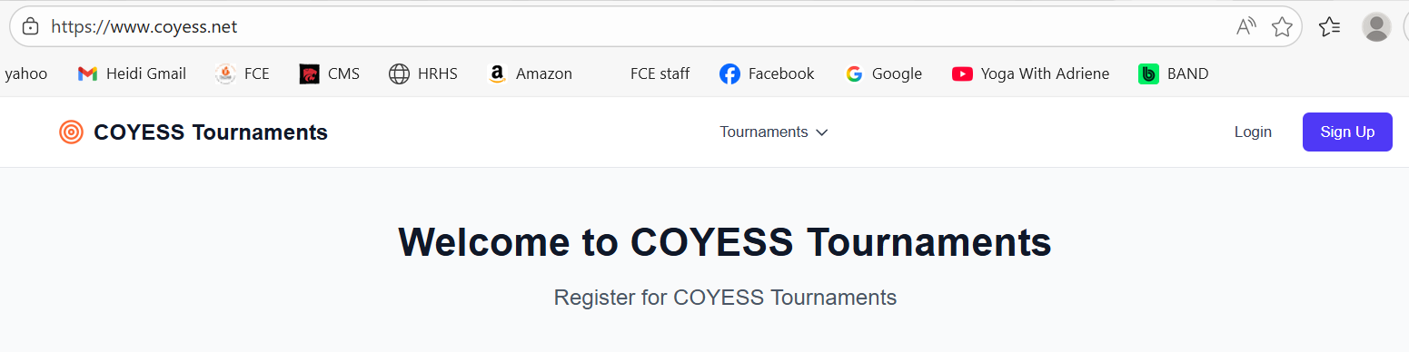

To create a new coaches account, select the “Sign Up” button in the top right corner.
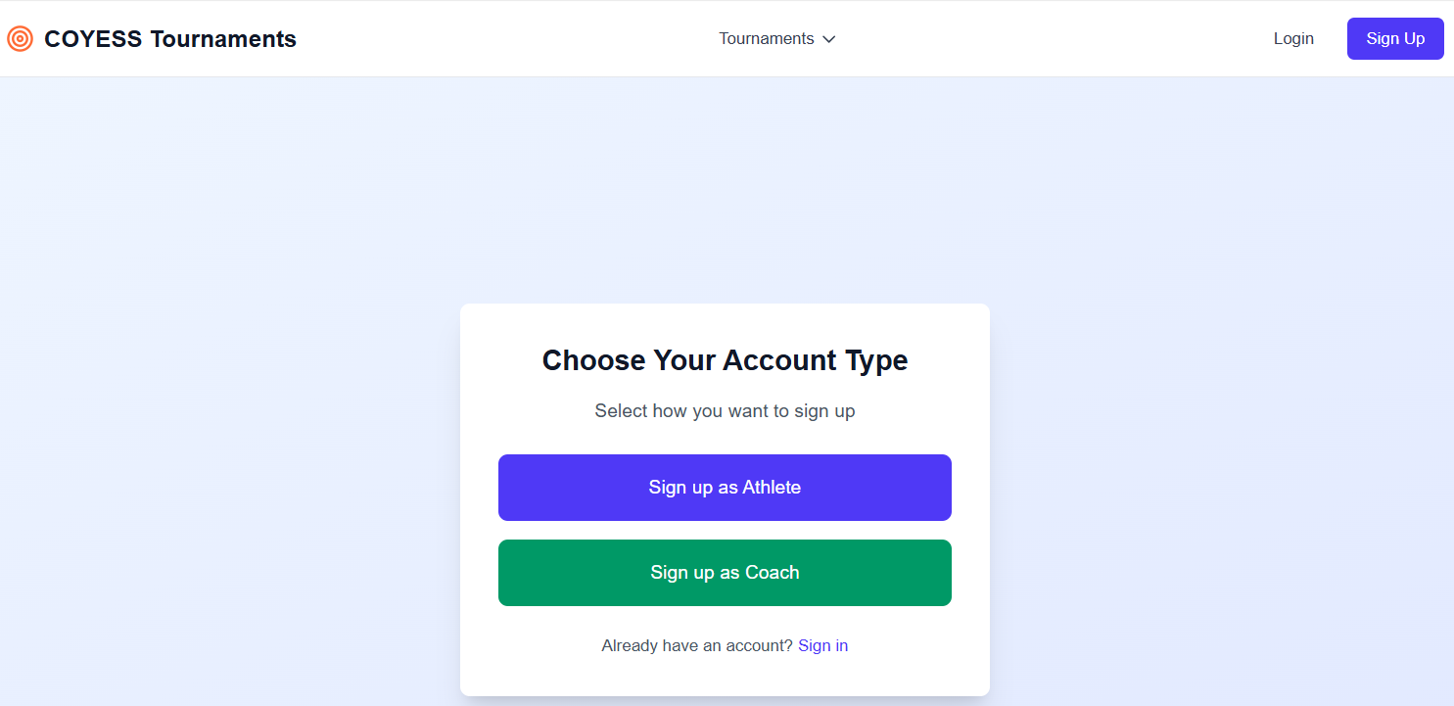

Select the “Sign up as Coach” button. Enter key information including a secure password for your login. Once you have filled in all the details, select the “Create Coach Account” button at the bottom.
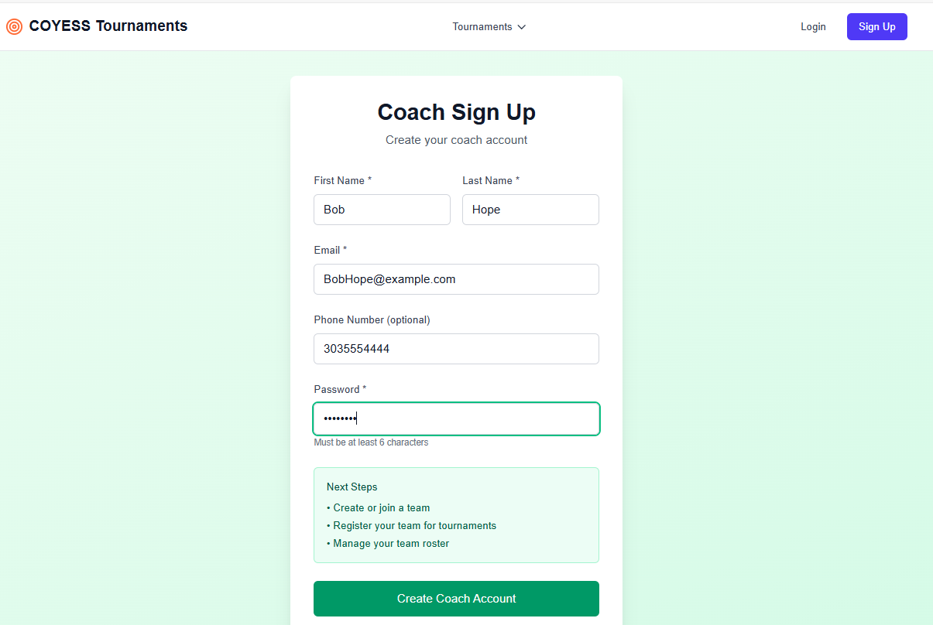

Once it creates your account, it will redirect you to the main page.
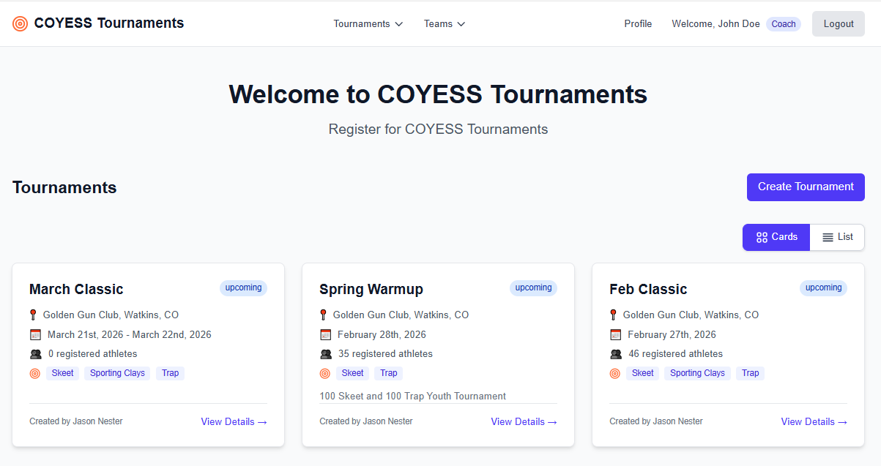

In the top right corner select the Profile link to update any remaining details around your profile. You can also change your password from this page.
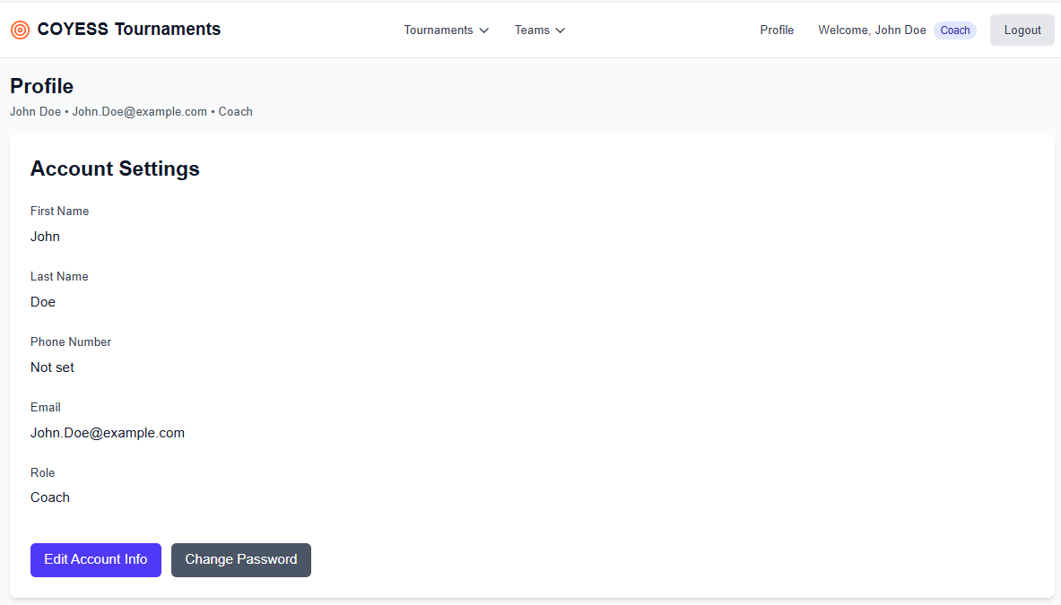

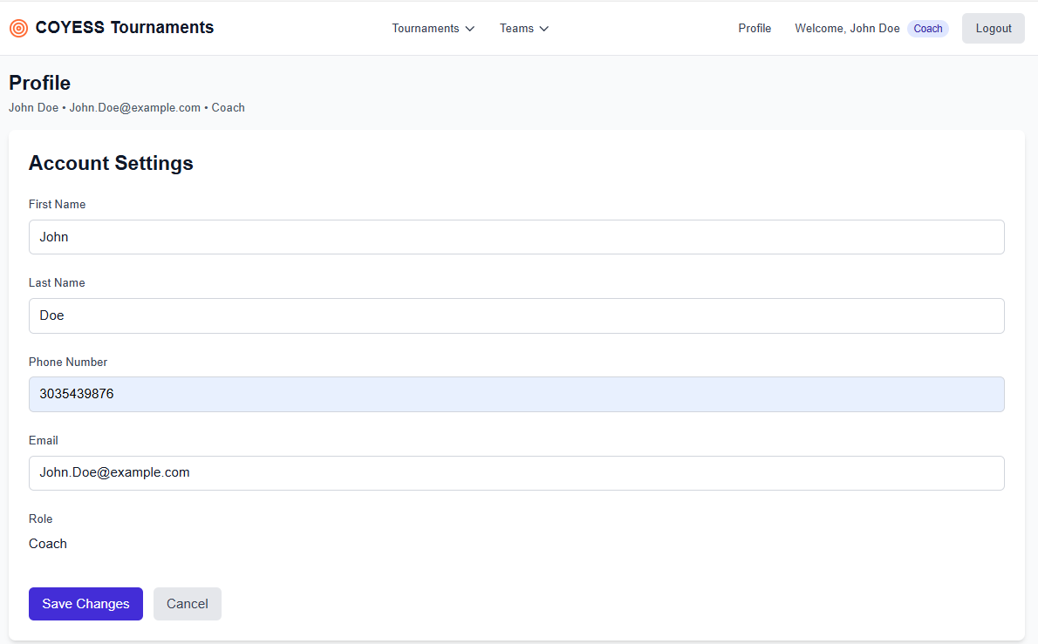

Once you have saved your profile changes, go back to the top of the web page and hover over the “Team” menu and see the drop down. Select the “Browse Teams” option.
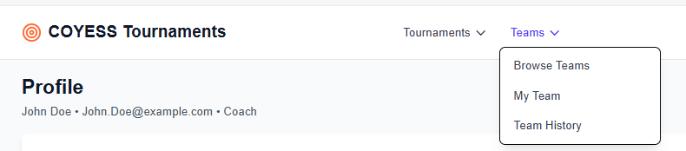

You will be redirected to the Teams page and in the upper right corner select the “+ Create New Team” button.
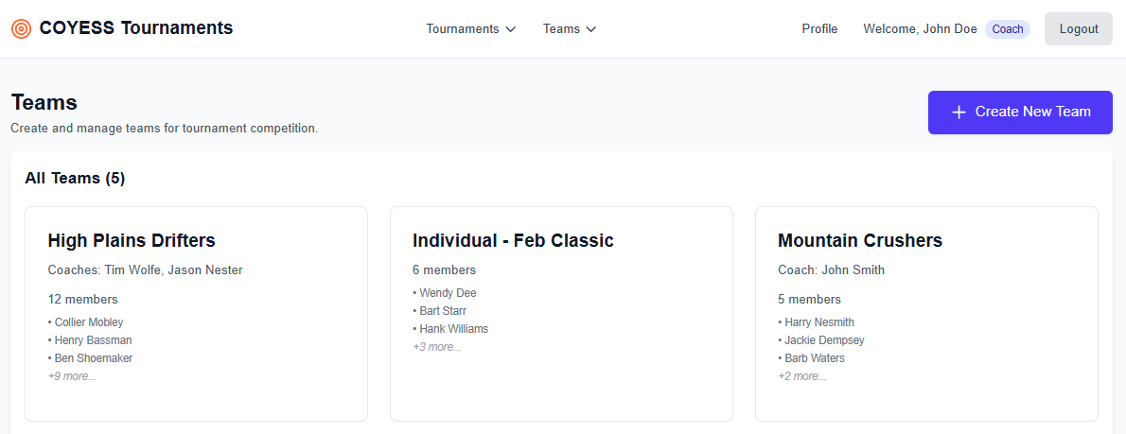

Fill in the Team information as well as the head coach information. The head coach information should match the coach profile just created.
Please enter a valid phone number, preferably your cell number, and your address. We need these to contact you in an emergency during the tournament. We need your address in case we need to mail awards to your athletes after the tournament.

Once completed press the “Create Team” button.
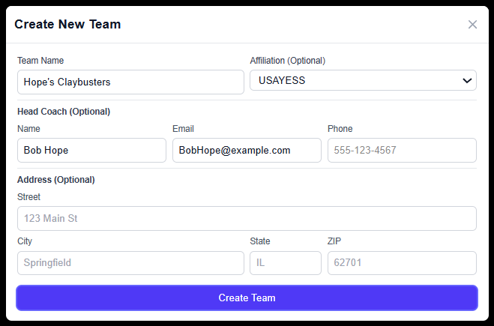

Once it creates your team, it will redirect you to a page that shows your team and allows you to manage it. Select the “Manage Team” button.
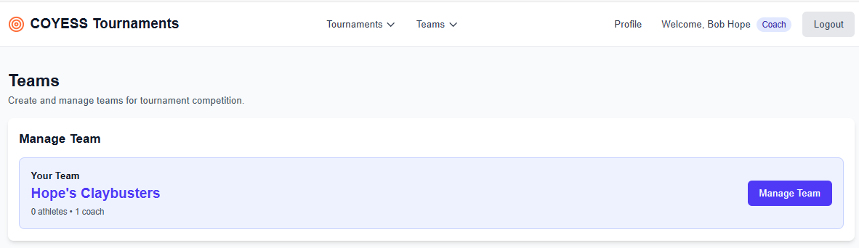

On the Manage Team page you can update your logo. You can also add coaches and athletes. Once a coach has created an account they can request to join. Those instructions are below. If you log into your account and go to the “Manage Team” menu option from the “Teams” menu, you will see pending coach requests.
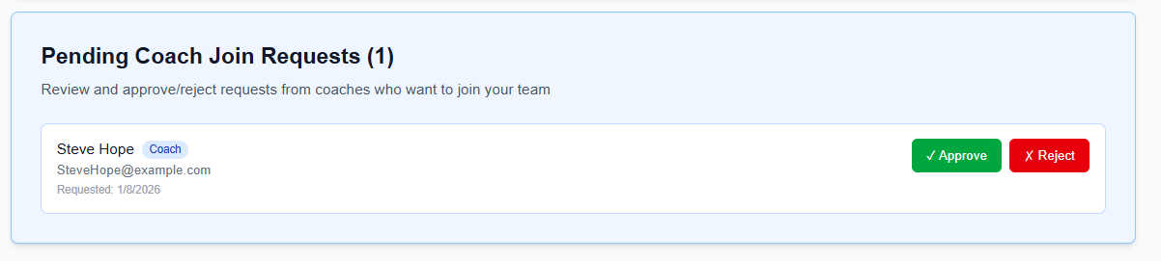
You can approve or reject coach requests to your team. Once a coach has been added they have the same rights as you do. They can assign athletes, register the team and team athletes for tournaments, squad athletes in a tournament, and other administrative tasks.

If your athletes have not registered individually yet, you will not be able to add them. We recommend at this point to sign out and request that your athletes create individual accounts. Once they have created their individual accounts, they can request to join your team, or you can select them and add them to your team.
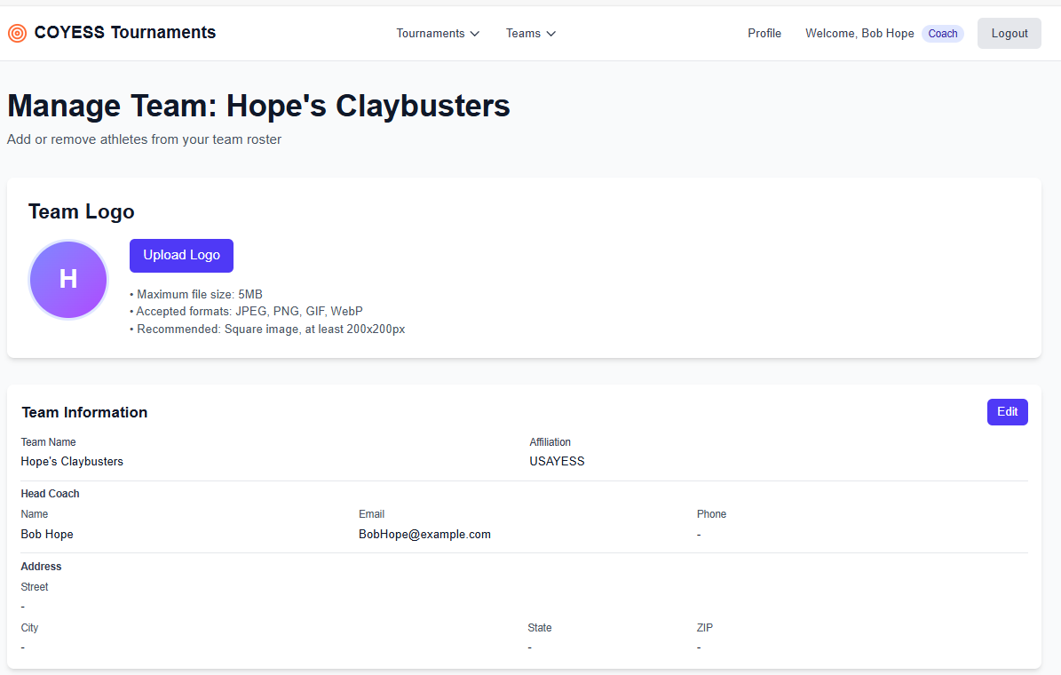

Once athletes are in the system you will see them listed below the Current Roster section. You can select them and add them to your team. Please do not add any athletes that are not part of your formal team.
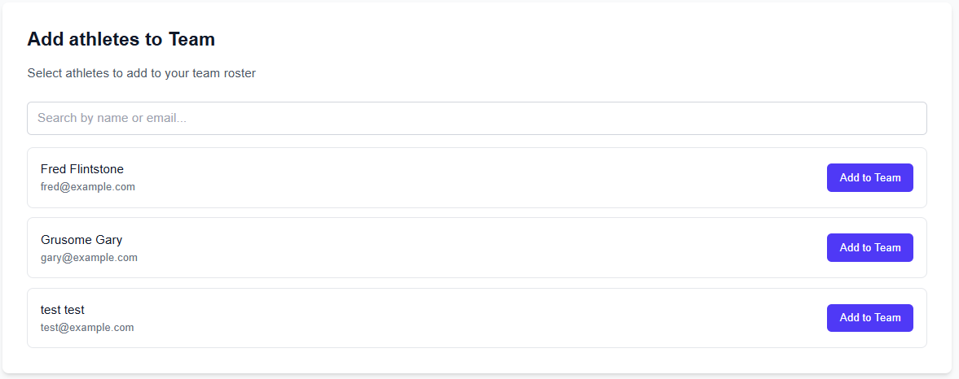

After your athletes have registered, if you log into your account and go to “Manage Team” from the “Teams” menu at the top, you might see athletes that have requested to join your team.
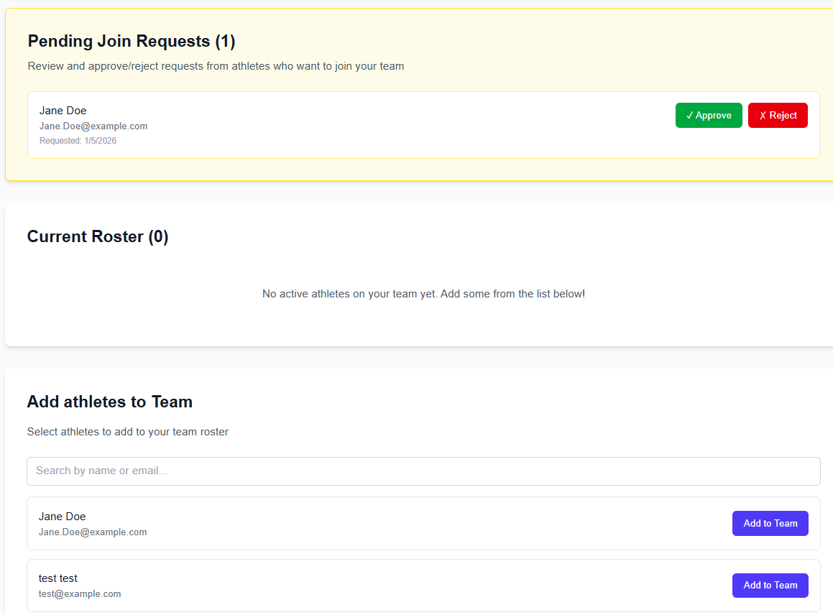

Once you have accepted requests from athletes or added your athletes to your team your roster should update and show all the athletes assigned to your team.
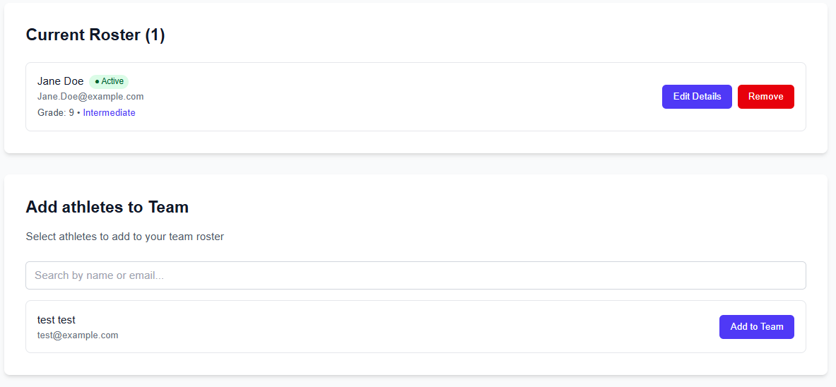

Assistant Coach Creation

Create your login just like the instructions at the top for the head coach.
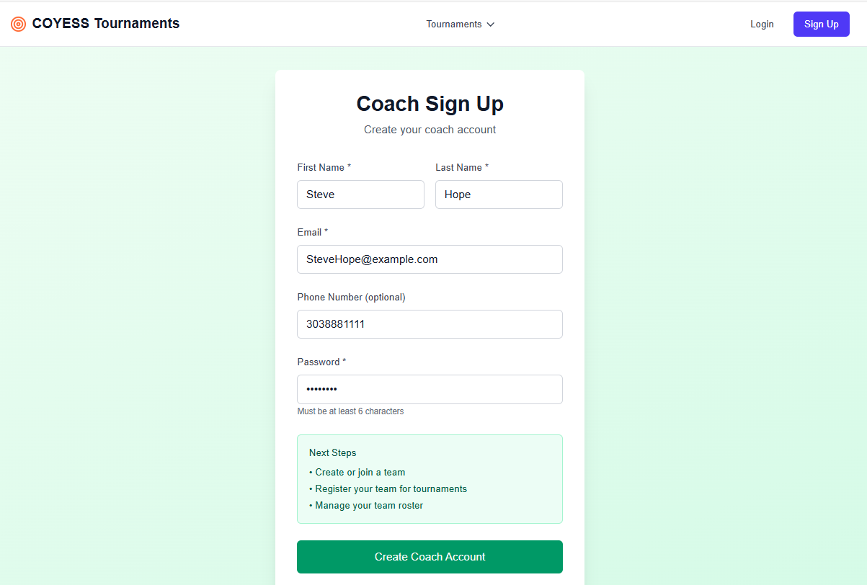

Make sure you review all of your information in your profile and update any missing data.
To be assigned to a team you need to send an email to one of the tournament administrators and request to be added to your team. Only the head coach can assign himself to the team he creates.

Assistant coaches do not need to create teams. They can be assigned to their team by an administrator or they can request to join a team. Select the “Teams” menu at the top and select the “Browse Teams” option in the dropdown menu.

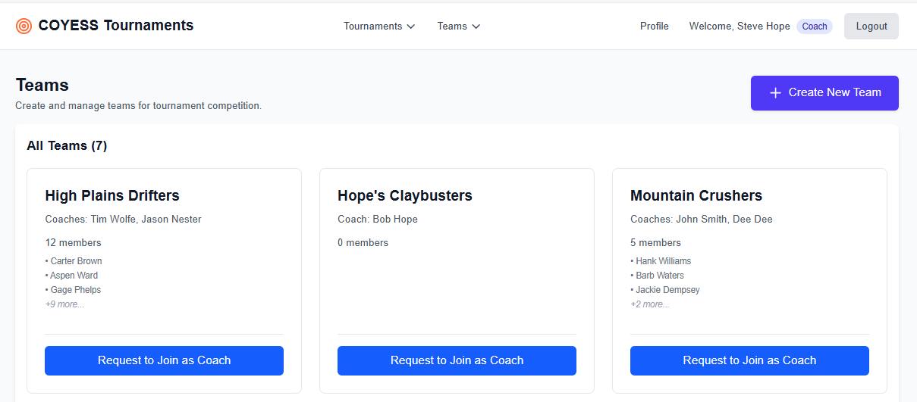

Select the Request to Join as Coach button for the team you wish to join.
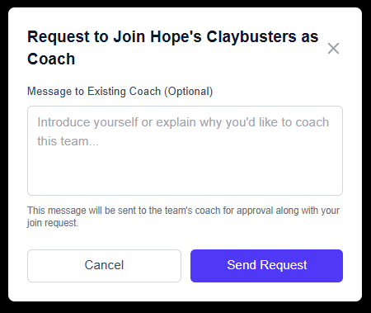

Wait for your request to be approved by the head coach.
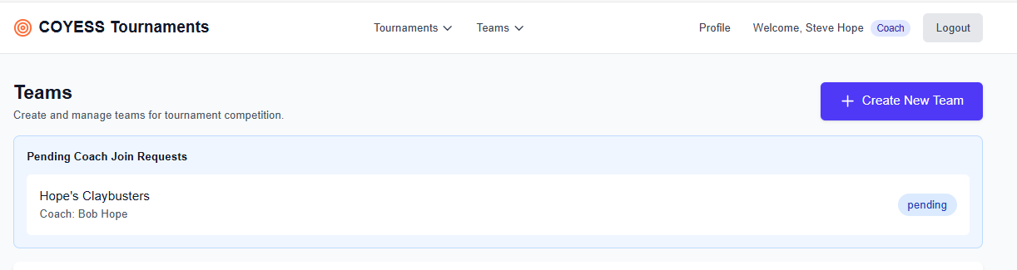
Once your request has been approved, if you log into the site and go to “My Teams” menu option from the “Teams” menu, it will take you to the team you are assigned to.
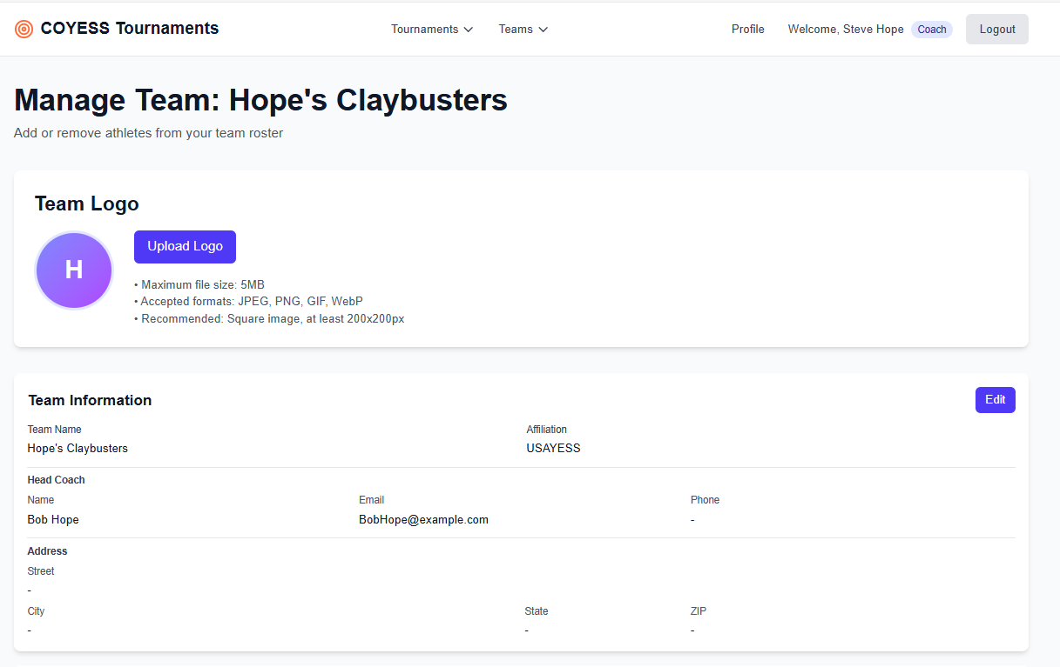
This completes the initial setup of the coach and team.

